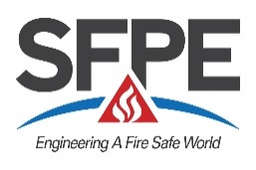 | Society of Fire Protection Engineers

Fire Service Scholarship Application

Applicant Information
Full Name:
 | Last | First | M.I.
Address:
 | Street Address |  | Apartment/Unit #
 | City | State | ZIP Code
Phone: | ( )

Fire Department:

Candidate Responses
This information will be reviewed to award the 2018 scholarships.

Why would you like to attend the 2018 SFPE North American Conference and Expo?

In what ways do you use or apply fire protection engineering in your current role within the fire department?

How did you hear about this application?
☐ | SFPE website | ☐ | SFPE email | ☐ | Co-workers
☐ | LinkedIn | ☐ | Twitter | ☐ | Website
☐ | Other

