Walk Like MADD Walk Team Registration
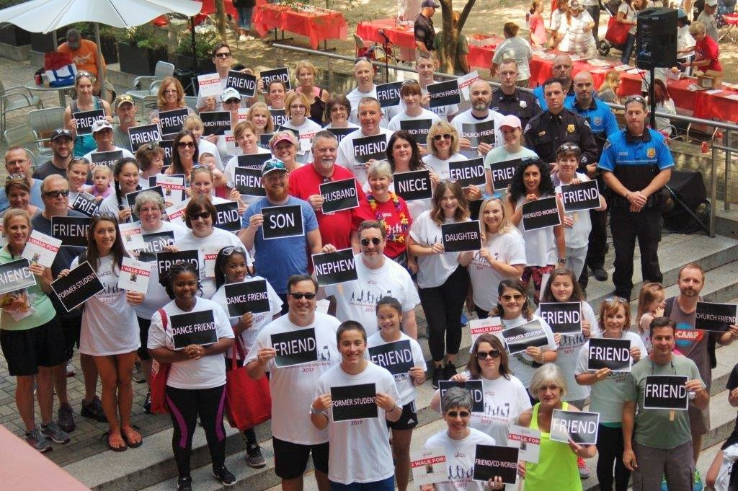
Your team doesn’t have to have 90 walkers like Rita’s Team but, as Team Captain, ask family, friends, co-workers who will support you by walking with you.

WALK LIKE MADD COLUMBIA
Saturday, April 14, 2018

Criminal Justice Academy
5400 Broad River Rd, Columbia

Register now at www.walklikemadd.org/columbia

Or register on-site 5-6 pm
Ceremony 6:30 pm
5K (3.1 mi) Walk 7-8:30 pm
Sent-off Law Enforcement for DUI checkpoints 9 pm

Adult walkers $20, Youth walkers $15 includes WLM t-shirt

Call (803) 748-7333 for more information/assistance

