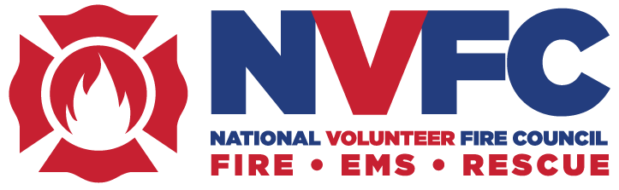

NVFC Tackles OSHA Proposed Standard, Honors Award Recipients at 2024 Spring Meeting

The National Volunteer Fire Council (NVFC) held its annual board of directors meeting on April 25-27 in Arlington, VA. Sixty-eight directors from 43 states were in attendance, including Keith Minick and Jack Kirlin from South Carolina. The board conducted Council business, held committee meetings, heard from guest speakers, and honored its achievement award recipients. A pressing issue addressed during the meeting was the proposed OSHA Emergency Response Standard.

Committees and Sessions

Several of the NVFC’s committees met on a range of issues including hazmat response, wildland, recruitment and retention, legislative, membership, and health, safety, and training. The EMS/Rescue Section also held its bi-annual meeting. General sessions were held with the full board to discuss matters of national and state interest, vote on issues before the board, and provide input and strategic direction for the organization.

OSHA Task Force

The NVFC board created a task force to address concerns around the Occupational Safety and Health Administration’s (OSHA) proposed Emergency Response Standard, which is intended to replace the 44-year-old Fire Brigade Standard. If enacted in its current form, the standard will place new requirements on fire and emergency services that will be burdensome, and in many cases impossible, for volunteer departments to comply with. This would have a devastating impact on local volunteer departments, forcing many to close or else operate outside of the federal standard, leaving them open to fines, citations, and huge civil liability exposure.

The board adopted a “call to action” statement on the issue and directed the newly formed task force to create a landing page with resources and tools to help responders understand the issue and submit a comment to OSHA during the public comment period. The NVFC is also working on developing its comment prior to the June 21 deadline. Learn more, read the statement, and access the public comment guide at www.nvfc.org/osha-standard.

Guest Speakers

The NVFC was pleased to welcome National Fire Academy Superintendent Eriks Gabliks as the keynote speaker at the Chairman’s Lunch on April 26. In addition, the board heard presentations from the following speakers:
- Chief Thomas Jenkins (Ret.), senior advisor and research manager, UL Fire Safety Research Institute, provided an update on the National Emergency Response Information System (NERIS).
- Gary McCarraher, senior public safety advisor for FirstNet Authority, gave an update on FirstNet.
- Dr. Richard Tedeschi, PhD, executive director of Boulder Crest Institute for Posttraumatic Growth, presented on the Boulder Crest approach.

Awards Banquet

An awards banquet was held on April 26 to recognize the recipients of the NVFC’s annual fire service achievement awards:
- Lifetime Achievement Award, sponsored by Lincoln Financial Group – Stephen Austin (DE)
- Chief James P. Seavey Sr. Health & Wellness Leadership Award, co-sponsored by VFIS and Ward Diesel Filter Systems – Chief John Swan Sr. (IL)
- Junior Firefighter of the Year, sponsored by California Casualty – Joseph Valentino (NJ)
- Junior Firefighter Program of the Year, sponsored by California Casualty – Inver Grove Heights (MN) Fire Department Explorer Program, which will receive their award during a local ceremony so that all of their juniors can participate

Read about this year’s award winners at https://bit.ly/2024-NVFC-Awards.

Two directors were honored with the E. James Monihan Director Award, sponsored by Provident, for their outstanding achievements on the board that went above and beyond normal expectations:
- Ron Roy (WA) was recognized posthumously for his work in the wildland arena, including the creation of the Wildland Fire Assessment Program and helping to plan the inaugural Regional Wildland Symposium. His wife, Martie Roy, was present to accept the award.
- Past chair Kevin Quinn (RI) was recognized for his many contributions to furthering the mission of the NVFC, expanding relationships with other fire service groups, and championing health and safety initiatives.

Sponsors

The NVFC is grateful to the support of our sponsors who helped make the meeting possible: Anheuser-Busch Foundation, California Casualty, Clarion Fire & Rescue Group, Columbia Southern University, ESIP, FirstNet Authority, Lincoln Financial Group, National Fire Protection Association, Provident, Tesla, VFIS, Ward Diesel Filter Systems, and Wendell’s Mint.

Next Meeting

The NVFC board is comprised of up to two representatives from 47 state associations and meets twice a year in the spring and fall. The next meeting is scheduled to take place on September 18-20 in Kansas City, MO. Learn more about the NVFC at www.nvfc.org.

